- Create and explore a data frame exam_data with name, score, attempts, and qualifying fields. Perform extract, add row/column, sort, save to file.

Aim:
To create and explore a data frame exam_data with name, score, aflempts, and qualifying fields. Perform extract, add row/column, sort, save to file.

Procedure:
Step 1: Open RStudio or R console on your computer.
Step 2: Create a data frame with student details such as name, score, aflempts, and qualification status.
Step 3: Add a new student record to the existing data frame using the rbind function. Step 4: Add a new column named grade to assign grades for each student.
Step 5: Arrange the data in descending order based on the score column. Step 6: Save the final data frame as a CSV file using the write.csv function.Step
Code:
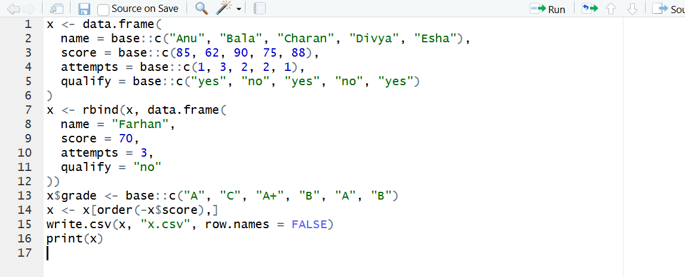

Output:
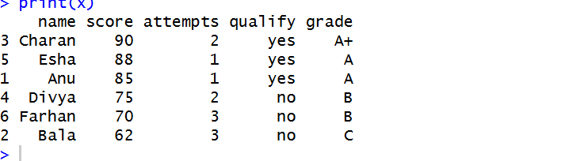
Result:
Hence the output is verified successfully.

